Oxidative stress promotes gasdermin D pore formation (Aptos Body, 12, Bold)

Elvira Boršić¹, Pascal Devant², Elsy Ngwa², Jay Thiagarajah², Charles Evavold³, Jonathan Kagan² and Iva Hafner Bratkovič^{1,4} (Aptos Body, 12, underline the presenting author)

¹Department of Synthetic Biology and Immunology, National Institute of Chemistry, 1000 Ljubljana, Slovenia
²Division of Gastroenterology, Boston Children's Hospital and Harvard Medical School, 300 Longwood Avenue, Boston, MA 02115, USA
³Ragon Institute of MGH, MIT and Harvard, 400 Technology Square, Cambridge, MA 02139, USA.
⁴EN-FIST Centre of Excellence, 1000 Ljubljana, Slovenia
Iva.Hafner@ki.si (Aptos Body, 11, Italic)

Abstract (Aptos Body 11)
Multiprotein complexes inflammasomes are central components of the early immune response to invading pathogens. Upon sensing infection or disrupted tissue homeostasis, inflammasome sensors through oligomerization lead to the assembly of inflammasomes and activation of inflammatory caspases. Gasdermin D is a substrate of inflammatory caspases. In a dormant state, gasdermin D molecules are present in the autoinhibited form, while cleavage and lipid binding recognition of negatively charged phospholipids enable the N-terminal domain of Gasdermin D to form pores in the membranes and facilitate pyroptotic cell death.
It was unknown, whether it is possible to regulate pore formation and pyroptosis after gasdermin D cleavage has already occurred. We used a forward genome-wide genetic screen that identified the Ragulator-Rag complex as being necessary for gasdermin D pore formation¹. Mechanistic analysis revealed that Ragulator-Rag/mTORC1 axis stimulates reactive oxygen species production that enhances pore formation downstream of gasdermin D cleavage. We further demonstrated that microbial components and environmental toxins induce ROS that promote GSDMD pore-forming activity through direct modification of C192².
These results reveal new options for the suppression of pyroptosis and novel interventional strategies for inflammatory diseases.
References (optional) (Aptos Body 9):
1 Evavold, C. L. et al. Control of gasdermin D oligomerization and pyroptosis by the Ragulator-Rag-mTORC1 pathway. Cell 184, 4495-4511 e4419, doi:10.1016/j.cell.2021.06.028 (2021).
2 Devant, P. et al. Gasdermin D pore-forming activity is redox-sensitive. Cell Rep 42, 112008, doi:10.1016/j.celrep.2023.112008 (2023).
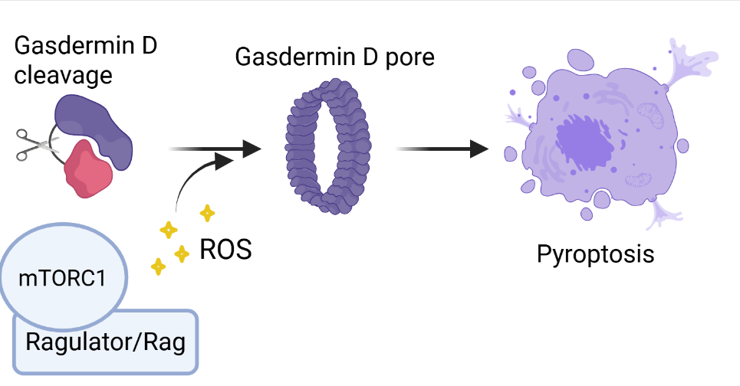
Graphical abstract (optional)

